TITLE
Must be short, concise, and clear, avoiding excessive prepositions and articles. A maximum of 20 words is advised, excluding formulas, patented names, abbreviations, or acronyms.

TITLE IN ENGLISH
Translate the Spanish title into English.

AUTHOR(S)
For each author, include: EMAIL | AFFILIATION | ORCID CODE. Academic degrees and hierarchical positions are not included. The first author of the manuscript is considered the main author.

CORRESPONDENCE
Correspondence email
email@email.com

ABSTRACT
Should be between 150 and 250 words and include an English translation (Abstract). It must be sufficiently concise and informative to allow the reader to identify the content and interest of the work and decide whether to read it. It must be written in the past tense and refer to the place and date of execution; in addition, it must contain the methodological procedure of the work, summarized objectives, and only hint at its main results and conclusions.

KEYWORDS
Usually include the studied taxa from most to least important. There may be 3 to 10 significant words that serve to label the article, separated by commas, and must be in English and in the article's native language. All keywords must be registered in the Health Sciences Descriptors (DeCS) and Medical Subject Headings (MeSH).

ABSTRACT
Translate the Spanish abstract into English.

KEYWORDS
Translate the keywords into English.

INTRODUCTION
Describes the conceptual or theoretical stage of the research, allows the reader to understand the general problem, so they can comprehend and evaluate the study's results. It should always be a reasoned justification of the research and a formulation of the problem or question in precise and understandable terms. It should be written to highlight the need for the study and stimulate the reader's curiosity. It should not be lengthy and must define the study's objective in the last paragraph. It should be written in the present tense, as it refers to the study problem and the knowledge about the topic at the start of the work.

MATERIALS AND METHODS
This is the planning and design stage of the study. Its purpose is to describe and explain how the research was conducted, so another author can replicate the study and verify the results independently. It must be written in the past tense, as it describes what happened during the research. It must contain the following sections: Design, Population or sample, Setting (where the study was conducted and its duration), Interventions (techniques, treatments, measurements used to collect information), Analyzed variables, and Statistical analysis.

RESULTS
Should be brief, clear, and written in the past tense, as it describes what was found in the research. This section includes tables, graphs, and figures. Tables must be interpretable without referring to the text, with simple design and appropriate writing. Graphs must clearly convey the message and show the numerical values of the statistics. Their function is to present the most important results in relation to the study's objectives. They only describe the obtained data without interpreting them.

TABLES
Table 1. Table Title.
Header 1 | Header 2 | Header 3
Information | Information | Information
Information | Information | Information
Information | Information | Informan

FIGURES
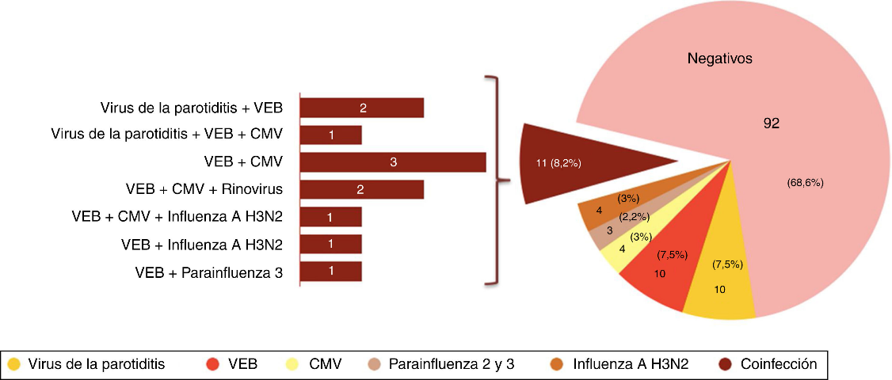
Figure 1. Title and description of the figure.
If several images form one figure, each image should be labeled as A and B, etc. The description of each image will be placed after the figure legend, according to the following example.
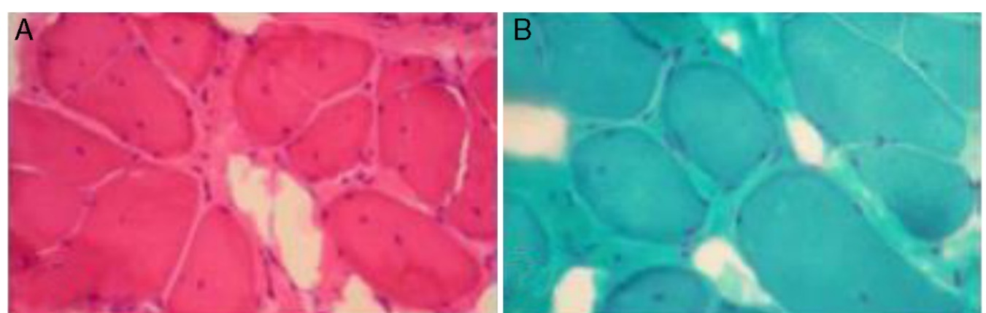
Figure 1. Figure Legend. In A. Description. In B. Description.

DISCUSSION
This section reflects the analysis and meaning of the results obtained in the research. It begins with the answer to the research objective and the initial question from the introduction, comparing the findings with other studies. At the end, conclusions of the study may be formulated, which is nothing more than the answer to the question posed at the beginning of the research. It is written in the present tense, as the work's findings are already considered scientific evidence.

CONCLUSIONS
This section summarizes what was found in the results and discussion, summarizing the work and its current status, proposing future objectives, and suggesting new approaches to follow in the research line. The conclusion is the answer to the research objective. The main results must be combined to write the conclusion. There should not be a conclusion for each result, and conclusions should not be based on reviewed literature.

ETHICAL CONSIDERATIONS
It must be ensured that the content is original and free of plagiarism, citing all sources correctly. Data must be real and presented clearly and honestly. If information from people is used, their consent must be obtained, and their privacy protected. It must detail whether the study was evaluated by an ethics committee. If not, an explanation must be provided as to why the study was not evaluated by an ethics committee.

CONFLICT OF INTEREST
Possible conflicts of interest arising from the manuscript submitted for publication must be stated.

ACKNOWLEDGMENTS
(Optional) applicable to institutions or individuals who supported the research. Any publication funded by the University of El Salvador must include a statement saying: "This research was conducted with the financial support of the University of El Salvador, Central America."

BIBLIOGRAPHIC REFERENCES
Only references directly cited in the manuscript should be listed under this heading, and they must be formatted according to Vancouver style. At least 60% of the references used must be no older than 5 years.

