TITLE IN SPANISH
Must be short, concise, and clear, avoiding excessive prepositions and articles. A maximum of 20 words is advised, excluding formulas, patented names, abbreviations, or acronyms.

TITLE IN ENGLISH
Translate the Spanish title into English.

AUTHOR(S)
For each author, include: EMAIL | AFFILIATION | ORCID CODE. Academic degrees and hierarchical positions are not included. The first author of the manuscript is considered the main author.

CORRESPONDENCE
Correspondence email:
email@email.com

ABSTRACT
Should be between 150 and 250 words and must be sufficiently concise and informative to allow the reader to identify the content and interest of the work and decide on reading it. It must be written in the past tense and refer to the place and date of execution. In addition to containing summarized objectives, it contains the methodological procedure of the work, giving hints only of its main results and conclusions.

KEYWORDS
Usually include the studied taxa from most to least important. There can be 3 to 10 significant words that serve to label the article, separated by commas. All keywords must be registered in the Health Sciences Descriptors (DeCS) and Medical Subject Headings (MeSH).

ABSTRACT
Translate the Spanish abstract into English.

KEYWORDS
Translate the Spanish abstract into English.

INTRODUCTION
This section should expand on the abstract and lay the foundation that provides the context your article will address. First, present the topic by explaining why it is interesting or significant, what has been published, and the advances the topic has had in recent years. Ideally, the introduction should conclude with a clear description of the scope, a reasoned justification for the research, and a formulation of the problem or question in precise and understandable terms. It contains the general structure of the article, i.e., a review of the main topics that will be covered and the order in which they will be addressed to provide the reader with the necessary background information to understand the following sections. Use relevant primary research articles published in the last 2 to 3 years. It should be written to highlight the need for the study and stimulate the reader's curiosity. It should not be lengthy and must define the study's objective in the last paragraph. It must be written in the present tense, as it refers to the study problem and the current knowledge on the topic.

TOPIC DEVELOPMENT
This section organizes the collected information using subtitles that give order and coherence to the text, integrating and classifying the data to fulfill its purpose. This section includes the theoretical support from original sources that justifies the structure and relevance of the article, highlighting the most important findings. When identifying references, use a variety of sources, such as bibliographic databases and community-specific resources. Furthermore, tables, figures, or diagrams—either original or taken from a bibliography (presented in Vancouver format)—can be used to summarize or illustrate information on central concepts; these visual elements are powerful tools to enhance understanding and can help readers grasp complex ideas quickly, always accompanied by interpretations that lead to clear and precise conclusions. Conclude your review with a perspectives section that summarizes the key conclusions and highlights future directions in the field, pointing out concrete goals for action. In the end, readers should have a clear understanding of the current state of the field, its future challenges, and the necessary steps to overcome them. Ideally, the reader will gain many ideas for new experiments and collaborations.

TABLES
Table 1. Table Title.
Header 1 | Header 2 | Header 3
Information | Information | Information
Information | Information | Information
Information | Information | Informan

FIGURES
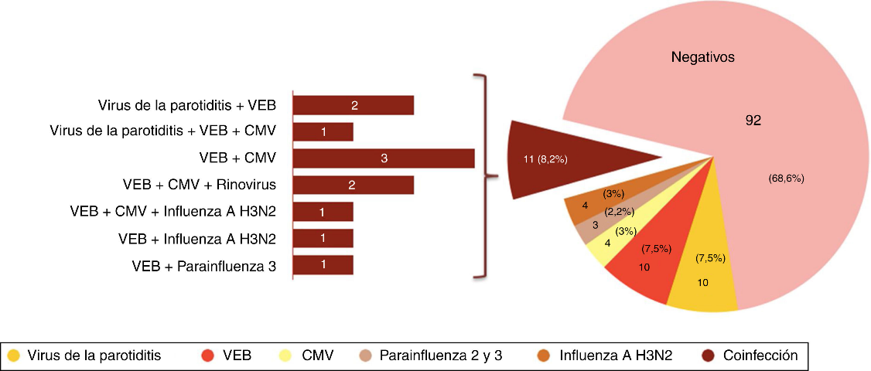
Figure 1. Title and description of the figure.
If several images form one figure, each image should be labeled as A and B, etc. The description of each image will be placed after the figure legend, according to the following example.
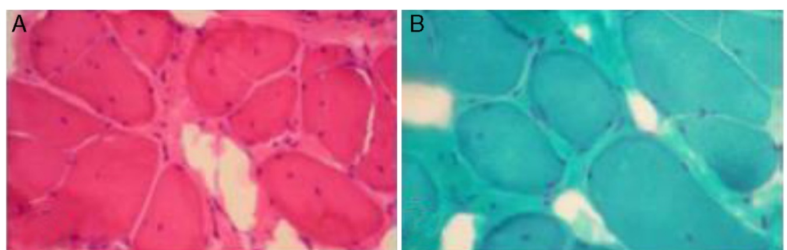
Figure 1. Figure Legend. In A. Description. In B. Description.
Conclude your review with a perspectives section that summarizes the key conclusions and highlights the future directions of the field, pointing out concrete goals for action. In the end, readers should have a clear understanding of the current state of the field, its future challenges, and the necessary steps to overcome them. Ideally, the reader will gain many ideas for new experiments and collaborations.

CONCLUSIONS
These are the author's reflections based on the analysis of the consulted sources, written with clarity, logic, and coherence. They must respond to the text's objectives, highlight the most relevant findings, and show interpretations, generalizations, relationships, recommendations, as well as possible discrepancies with other research reviewed in the background and theoretical framework.

THE MANUSCRIPT'S WORD COUNT FROM INTRODUCTION TO CONCLUSIONS, NOT INCLUDING TABLES AND FIGURES, MUST NOT EXCEED 8,000 WORDS.

ETHICAL CONSIDERATIONS
It must be ensured that the content is original and free of plagiarism, citing all sources correctly. Data must be real and presented clearly and honestly. If information from people is used, their consent must be obtained and their privacy protected.

CONFLICT OF INTEREST
Possible conflicts of interest arising from the manuscript submitted for publication must be stated.

ACKNOWLEDGMENTS
((Optional) Applicable to institutions or individuals who supported the research. Any publication funded by the University of El Salvador must include a statement that says: “This research was conducted with the financial support of the University of El Salvador, Central America.”

REFERENCES
Only references directly cited in the manuscript should be listed under this heading, and they must be formatted according to the Vancouver Style. At least 60% of the references used must be no older than 5 years.

USEFUL LINKS
Reyes BH. Artículos de Revisión. Rev Med Chile. 2020. 148: 103-108. http://dx.doi.org/10.4067/S0034-98872020000100103
Pardal-Refoyo, JL. Los artículos de revisión. orientaciones para los autores y revisores. Rev. ORL. 2023. 14(3): 171-174. DOI: https://doi.org/10.14201/orl.31646
Gulpınar O & Guçal Guçlu A. How to write a review article? Turk J. Urol. 2013. 39 (Supl 1): 44-8. https://doi:10.5152/tud.2013.054
Erol A. Basics of Writing Review Articles. Arch Neuropsychiatry. 2022. 59:1-2 https://doi.org/10.29399/npa.28093
How to write an excellent Review article. Nat Rev Bioeng. 2024. 2, 907. https://doi.org/10.1038/s44222-024-00256-4

